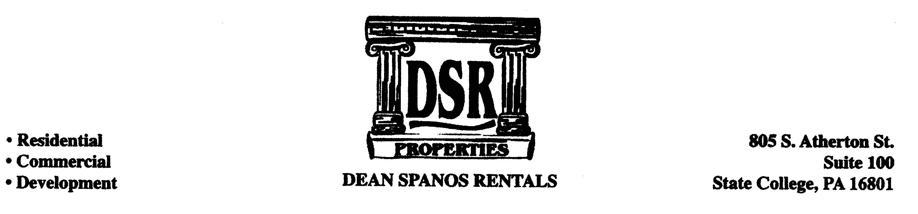

HOUSING APPLICATION

House Address:______________________________ Monthly Rent:______________

Group Contact:_________________________________ Referred by_____________
(Please designate only one person as group leader)

Applicant’s Information:

______________ _______________ ______________________
First Middle Last
______________ _______________ ______________________
SS # Birth date Driver’s License #/State
______________ _______________ ______________________
Cell Phone Home Phone PSU email address
______________ _______________ ______________________
Current Year(So,Jr,Sr) Major/Department Alternate Email Address

Current Residence: Previous Address:

________________________________ _______________________________
Address Address

________________________________ _______________________________
City, State, Zip Code City, State, Zip Code

________________________________ _______________________________
Current Landlord/Phone Number Previous Landlord/Phone Number

_______________ ______________ _______________ ______________
Total rent/mo. Months there Total Rent/mo. Months there

_______________ ______________ _______________ ______________
Your rent/mo. Size of house or apt. Your rent/mo. Size of house or apt.
(# of bedrooms) (# of bedrooms)

Present Employment:

____________________ _____________________
Employer Phone Number

______________________________ _______________________________
Address Position/Salary per month

______________________________ _______________________________
City, State, Zip Code Funding Besides Employment (Student Loans, etc)

Questionnaire: Circle One:

Will you need a Parking Space? Yes or No

Do you have a water bed? Yes or No

Do you plan to have a pet? Yes or No

Do you currently have an emotional support animal/service dog? Yes or No

If yes, what type of animal? ___________

Do you anticipate and are in the process of getting one? Yes or No

Have you ever been late with rent? Yes or No

Have you ever defaulted on bills? Yes or No

Have you ever been evicted? Yes or No

Have you ever been fined for violating
Rules and regulations of current or
Previous landlords or municipalities? Yes or No

Have you ever been arrested? Yes or No

Have you ever been convicted? Yes or No

Parents Information:

Father’s Information Mothers Information

_____________________________________________ _______________________________________
First Name Last Name First Name Last Name

_____________________________________________ _______________________________________
Home or Cell Phone Number Home or Cell Phone Number

_____________________________________________ _______________________________________
Address Address

_____________________________________________ _______________________________________
City, State, Zip Code City, State, Zip Code

Occupation:___________________________________ Occupation:_____________________________

Character References: not related to you! (Name and Email)

1.__________________________________________________________________

2.__________________________________________________________________

3.__________________________________________________________________

This application is submitted by applicant(s) and accepted by the owner of the subject premises (called Landlord as follows) for processing upon the following terms and conditions:

- This application is not a Landlord’s Agreement to Lease.

- Applicant(s) shall deposit the sum of one month’s rent when applicant(s) applies. Deposit is payable in one check. This deposit shall be returned to applicant(s) if the application is not accepted. If the application is accepted, the deposit shall be retained and applied as the security deposit upon execution and delivery of a written lease agreement.

- A $25 handling fee is required for all applications. When additional applicant(s) is (are) going to join the joint group or replace some applicant after the lease is signed, each additional alteration is required to pay $50 alteration fee.

- Applicant(s) acknowledges that in processing this application, Landlord has the right to make personal and credit inquiries of individuals and companies concerning applicant’s character, creditworthiness, general reputation, personal characteristics and mode of living. Applicants agree to furnish all the pertinent information and any additional information within 3 days or as Landlord reasonably specifies at the time of request. Otherwise, the application will be canceled and the $25/applicant processing fee will be retained by Landlord.

- Landlord shall not be liable to applicant(s) for refusal to accept this application to lease. Applicant acknowledges that Landlord, its agents and employees have made no written or oral representation whatsoever that this application would be accepted or that Applicant would be given a lease agreement for any dwelling unit. This deposit does not guarantee you a house/apartment at this time.

- Applicant(s) understand that, upon submitting application forms and the deposit, each applicant will be considered seriously committed. If Landlord disapproves the application, the deposit will be refunded to applicants in full. If application is approved, applicants shall be notified and a written lease agreement will be prepared. Upon notification and the date of signing the lease is scheduled, Applicant(s) shall have 24 hours to execute and sign the lease. If applicants fail to sign the lease within 24 hours of the scheduled date, the application will be considered withdrawn by Applicant(s).

Applicant(s)’ Acknowledgment of Responsibility

I understand and acknowledge that once I execute a lease agreement with the Landlord, even prior to commencement of the lease term contained in the lease agreement, if I attempt to cancel or withdraw from the lease or if I fail or refuse to execute any additional addenda, Landlord, at his sole discretion, may choose to re-rent the premises to someone else and my security deposit will be forfeited to Landlord. I will also remain liable for any and all other charges that are due under the terms and conditions of my lease agreement. I also agree that the lease that I will be signing is a JOINT AND SEVERAL LEASE. This means that all of the tenants as a group and each of the tenants as an individual are responsible to the Landlord for all of the agreements of this Lease including but not limited to the care and condition of the premises and any damages thereto. Landlord can sue all of the tenants(jointly) and (severally) for all of the unpaid rent and any damages to the property or for any other charges due under the terms of my lease agreement.

I HAVE READ AND UNDERSTOOD THE ABOVE TERMS AND CONDITIONS AND CERTIFY THAT THE INFORMATION INCLUDED IN THIS APPLICATION IS TRUE AND CORRECT TO THE BEST OF MY KNOWLEDGE.

APPLICANT’S SIGNATURE:_________________________________DATE:__________________

Please return completed application to:

DSR Properties
805 S. Atherton St.
Suite #100
State College, PA 16801

Email: deanrent@aol.com

